**Task 1 :**

**Binary**

Find the index of pen

array =[“pen”,”pencil”,”stabler”]

Get = “pen”

**Flow Chart :**

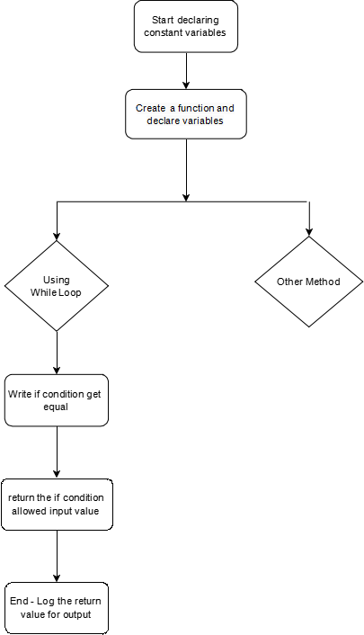

**Output :**

